Experiment 10:
To learn Software Configuration Management and provisioning using Puppet Blocks(Manifest, Modules, Classes, Function)
Puppet manifests are configuration files written in Puppet’s declarative language that define the desired state of system resources like packages, files, and services. They are the core building blocks of Puppet automation.
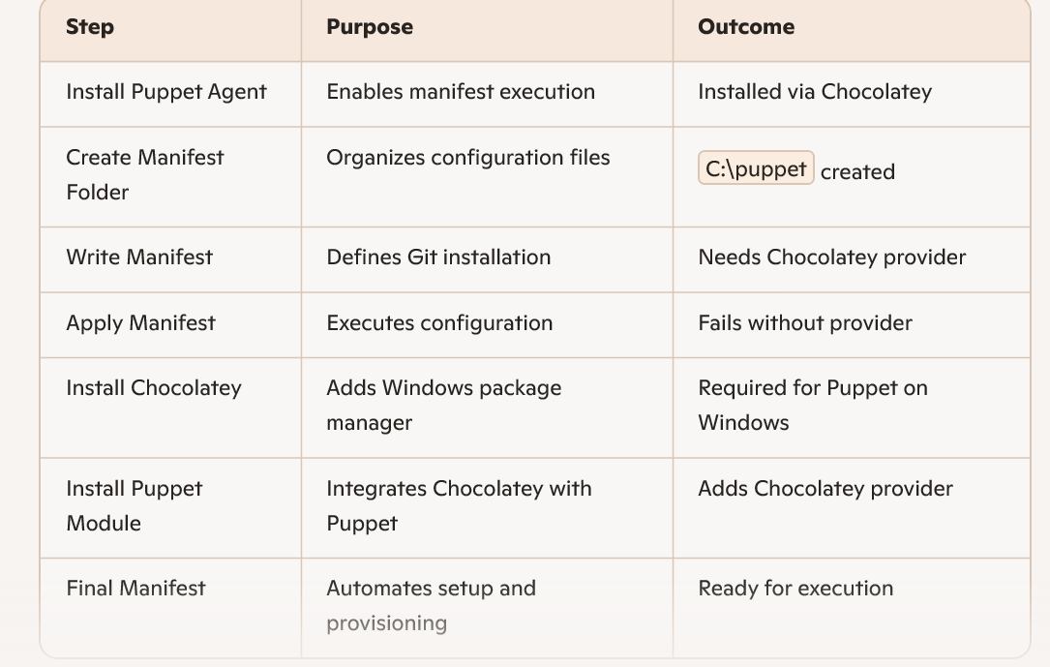

PS C:\Users\tejah> choco install puppet-agent

Do you want to continue?([Y]es/[N]o): y
PS C:\Users\tejah> New-Item -Path "C:\puppet" -ItemType Directory -Force
Directory: C:\

Mode LastWriteTime Length Name
---- ------------- ------ ----
d----- 07-10-2025 21:37 puppet

PS C:\Users\tejah> Set-Content -Path "C:\puppet\site.pp" -Value @"
>> class install_git {
>> package { 'git':
>> ensure => installed,
>> }
>> }
>>
>> include install_git
>> "@
PS C:\Users\tejah> Get-Content "C:\puppet\site.pp"
class install_git {
package { 'git':
ensure => installed,
}
}

include install_git

PS C:\Users\tejah> puppet apply C:\puppet\site.pp
Notice: Compiled catalog for laptop-qup1o2oi in environment production in 3.65 seconds
Error: The source parameter is required when using the Windows provider.
Error: /Stage[main]/Install_git/Package[git]/ensure: change from 'absent' to 'present' failed: The source parameter is required when using the Windows provider.
Notice: Applied catalog in 0.64 seconds
PS C:\Users\tejah> Set-ExecutionPolicy Bypass -Scope Process -Force
PS C:\Users\tejah> [System.Net.ServicePointManager]::SecurityProtocol = [System.Net.ServicePointManager]::SecurityProtocol -bor 3072
PS C:\Users\tejah> iex ((New-Object System.Net.WebClient).DownloadString('https://community.chocolatey.org/install.ps1'))
WARNING: 'choco' was found at 'C:\ProgramData\chocolatey\bin\choco.exe'.
WARNING: An existing Chocolatey installation was detected. Installation will not continue. This script will not
overwrite existing installations.
If there is no Chocolatey installation at 'C:\ProgramData\chocolatey', delete the folder and attempt the installation
again.

Please use choco upgrade chocolatey to handle upgrades of Chocolatey itself.
If the existing installation is not functional or a prior installation did not complete, follow these steps:
- Backup the files at the path listed above so you can restore your previous installation if needed.
- Remove the existing installation manually.
- Rerun this installation script.
- Reinstall any packages previously installed, if needed (refer to the lib folder in the backup).

Once installation is completed, the backup folder is no longer needed and can be deleted.
PS C:\Users\tejah> @"
>> class install_git {
>> package { 'git':
>> ensure => installed,
>> provider => 'chocolatey',
>> }
>> }
>>
>> include install_git
>> "@ | Out-File -FilePath "C:\puppet\site.pp" -Encoding ASCII
PS C:\Users\tejah> puppet apply C:\puppet\site.pp
Notice: Compiled catalog for laptop-qup1o2oi in environment production in 1.40 seconds
Error: Parameter provider failed on Package[git]: Invalid package provider 'chocolatey' (file: C:/puppet/site.pp, line: 2)
PS C:\Users\tejah> Set-ExecutionPolicy Bypass -Scope Process -Force
PS C:\Users\tejah> [System.Net.ServicePointManager]::SecurityProtocol = [System.Net.ServicePointManager]::SecurityProtocol -bor 3072
PS C:\Users\tejah> iex ((New-Object System.Net.WebClient).DownloadString('https://community.chocolatey.org/install.ps1'))
WARNING: 'choco' was found at 'C:\ProgramData\chocolatey\bin\choco.exe'.
WARNING: An existing Chocolatey installation was detected. Installation will not continue. This script will not
overwrite existing installations.
If there is no Chocolatey installation at 'C:\ProgramData\chocolatey', delete the folder and attempt the installation
again.

Please use choco upgrade chocolatey to handle upgrades of Chocolatey itself.
If the existing installation is not functional or a prior installation did not complete, follow these steps:
- Backup the files at the path listed above so you can restore your previous installation if needed.
- Remove the existing installation manually.
- Rerun this installation script.
- Reinstall any packages previously installed, if needed (refer to the lib folder in the backup).

Once installation is completed, the backup folder is no longer needed and can be deleted.
PS C:\Users\tejah> choco --version
2.5.1
PS C:\Users\tejah> puppet module install chocolatey-chocolatey
Notice: Preparing to install into C:/Users/tejah/.puppetlabs/etc/code/modules ...
Notice: Created target directory C:/Users/tejah/.puppetlabs/etc/code/modules
Notice: Downloading from https://forgeapi.puppet.com ...
Notice: Installing -- do not interrupt ...
C:/Users/tejah/.puppetlabs/etc/code/modules
└─┬ chocolatey-chocolatey (v1.2.6)
├── badgerious-windows_env (v2.2.2)
├── puppetlabs-powershell (v2.3.0)
└── puppetlabs-stdlib (v4.25.1)
PS C:\Users\tejah> @"
>> class chocolatey_setup {
>> exec { 'install_chocolatey':
>> command => 'Set-ExecutionPolicy Bypass -Scope Process -Force; iex ((New-Object System.Net.WebClient).DownloadString("https://community.chocolatey.org/install.ps1"))',
>> provider => powershell,
>> unless => 'choco --version',
>> }
>> }
>>
>> class install_git {
>> package { 'git':
>> ensure => installed,
>> provider => 'chocolatey',
>> }
>> }
>>
>> include chocolatey_setup
>> include install_git
>> "@ | Out-File -FilePath "C:\puppet\site.pp" -Encoding ASCII

